TastyTalks - An Engaging Social Platform for Food Enthusiasts, Chefs & Recipe Communities
(13 size) A Project Based Learning Report Submitted in partial fulfilment of the requirements for the award of the degree

of

Bachelor of Technology
in The Department of CSE
Full stack application development 24DCS02A

Submitted by
2410030076-Sreeja Kodali
2410030180-Shiva kumar Reddy
2410030228-Adithi Yadav
2410030229-Likitha Thumma
2410030232-Esha Manogna

Under the guidance of
Dr.Ratna Kumar



Department of Computer Science Engineering
Koneru Lakshmaiah Education Foundation, Aziz Nagar
Aziz Nagar – 500075
FEB - 2025.
ABSTRACT

TastyTalks is an engaging social platform created to connect food enthusiasts, home cooks, and professional chefs through an interactive and well-structured recipe sharing community. In today’s digital space, people depend on generic recipe websites, blogs, and social media groups to discover cooking ideas. However, these platforms often lack organization, credibility, proper moderation, and meaningful interaction between users and content creators. Recipes may be unreliable, poorly structured, or difficult to search, and users have limited opportunities to clarify doubts or engage with experienced chefs. TastyTalks is designed to overcome these limitations by introducing a dedicated, role-based culinary platform that emphasizes reliability, interaction, and community building.
The system defines three primary roles: Foodies (regular users), Chefs (content creators), and Admins (moderators). Chefs can create and publish detailed recipes with ingredients, preparation steps, images, and tags, while Foodies can explore recipes using advanced search and filtering options, rate them, comment, bookmark favorites, and follow chefs. Admins ensure quality and trustworthiness by approving recipes before publication, managing users, and monitoring content across the platform. This structured workflow ensures that only verified and meaningful content is shared within the community.
TastyTalks also enhances user engagement through features such as real-time community chat, notifications, chef leaderboards, profile management, and a points-and-badge system that rewards chefs for quality contributions. These elements promote healthy competition, recognition, and active participation among users. The platform is developed using React for an interactive frontend, Java Spring Boot in Eclipse for robust backend services, and MySQL for efficient database management, ensuring scalability, security, and responsive performance.
TastyTalks also enhances user engagement through features such as real-time community chat, notifications, chef leaderboards, profile management, and a points-and-badge system that rewards chefs for quality contributions. These elements promote healthy competition, recognition, and active participation among users.
Additionally, the platform encourages collaborative learning by allowing users to ask questions, share cooking tips, and interact directly within the community space. The integration of social features with recipe management transforms the platform from a simple recipe repository into a vibrant culinary network. By combining structured content sharing, moderation, and real-time interaction, TastyTalks aims to foster a supportive environment where users not only find recipes but also gain knowledge, confidence, and inspiration in their cooking journey.
Overall, TastyTalks aims to create a trustworthy, interactive, and community-driven environment where food lovers can discover recipes, learn from experts, share knowledge, and build meaningful culinary connections.
TABLE OF CONTENTS

S.No | Name | PageNo
1 | Introduction
2 | Methodology
3 | Experiments
4 | Results
5 | Conclusion and Future Work
6 | References

TASTY TALKS

Introduction
TastyTalks is an engaging social platform created to connect food enthusiasts, home cooks, and professional chefs through an interactive and well-structured recipe sharing community. In today’s digital space, people depend on generic recipe websites, blogs, and social media groups to discover cooking ideas. However, these platforms often lack organization, credibility, proper moderation, and meaningful interaction between users and content creators. Recipes may be unreliable, poorly structured, or difficult to search, and users have limited opportunities to clarify doubts or engage with experienced chefs. TastyTalks is designed to overcome these limitations by introducing a dedicated, role-based culinary platform that emphasizes reliability, interaction, and community building.
The system defines three primary roles: Foodies (regular users), Chefs (content creators), and Admins (moderators). Chefs can create and publish detailed recipes with ingredients, preparation steps, images, and tags, while Foodies can explore recipes using advanced search and filtering options, rate them, comment, bookmark favorites, and follow chefs. Admins ensure quality and trustworthiness by approving recipes before publication, managing users, and monitoring content across the platform. This structured workflow ensures that only verified and meaningful content is shared within the community.
TastyTalks also enhances user engagement through features such as real-time community chat, notifications, chef leaderboards, profile management, and a points-and-badge system that rewards chefs for quality contributions. These elements promote healthy competition, recognition, and active participation among users. The platform is developed using React for an interactive frontend, Java Spring Boot in Eclipse for robust backend services, and MySQL for efficient database management, ensuring scalability, security, and responsive performance.
The system defines three primary roles: Foodies (regular users), Chefs (content creators), and Admins (moderators). Chefs can create and publish detailed recipes with ingredients, preparation steps, images, and tags, while Foodies can explore recipes using advanced search and filtering options, rate them, comment, bookmark favorites, and follow chefs. Admins ensure quality and trustworthiness by approving recipes before publication, managing users, and monitoring content across the platform. This structured workflow ensures that only verified and meaningful content is shared within the community.
TastyTalks also enhances user engagement through features such as real-time community chat, notifications, chef leaderboards, profile management, and a points-and-badge system that rewards chefs for quality contributions. These elements promote healthy competition, recognition, and active participation among users. The platform is developed using React for an interactive frontend, Java Spring Boot in Eclipse for robust backend services, and MySQL for efficient database management, ensuring scalability, security, and responsive performance.
Additionally, the platform encourages collaborative learning by allowing users to ask questions, share cooking tips, and interact directly within the community space. The integration of social features with recipe management transforms the platform from a simple recipe repository into a vibrant culinary network. By combining structured content sharing, moderation, and real-time interaction, TastyTalks aims to foster a supportive environment where users not only find recipes but also gain knowledge, confidence, and inspiration in their cooking journey.
Overall, TastyTalks aims to create a trustworthy, interactive, and community-driven environment where food lovers can discover recipes, learn from experts, share knowledge, and build meaningful culinary connections.

METHODOLOGY
The development of TastyTalks follows a systematic and modular web application methodology that emphasizes role-based design, layered architecture, and interactive user experience. The methodology begins with requirement analysis, where the primary objectives of the platform are identified, including reliable recipe sharing, meaningful interaction between food enthusiasts and chefs, and effective content moderation. Based on these requirements, three distinct user roles—Foodie, Chef, and Admin—are defined to ensure structured participation and controlled access to system features. This role identification forms the foundation for designing the application workflow and access permissions.
Following requirement analysis, the system moves into the design phase, where the overall architecture, database schema, user interface layout, and API structure are planned. The platform is designed using a three-tier architecture consisting of the presentation layer (frontend), application layer (backend), and data layer (database). The frontend is developed using React to provide a responsive and dynamic user interface that allows users to browse recipes, interact through comments and ratings, manage profiles, and participate in community chat. The backend is implemented using Java Spring Boot in Eclipse, which handles business logic, authentication, authorization, RESTful API services, and real-time communication features. MySQL is used as the relational database to store and manage structured data such as users, recipes, comments, ratings, followers, bookmarks, chat messages, and leaderboard points.
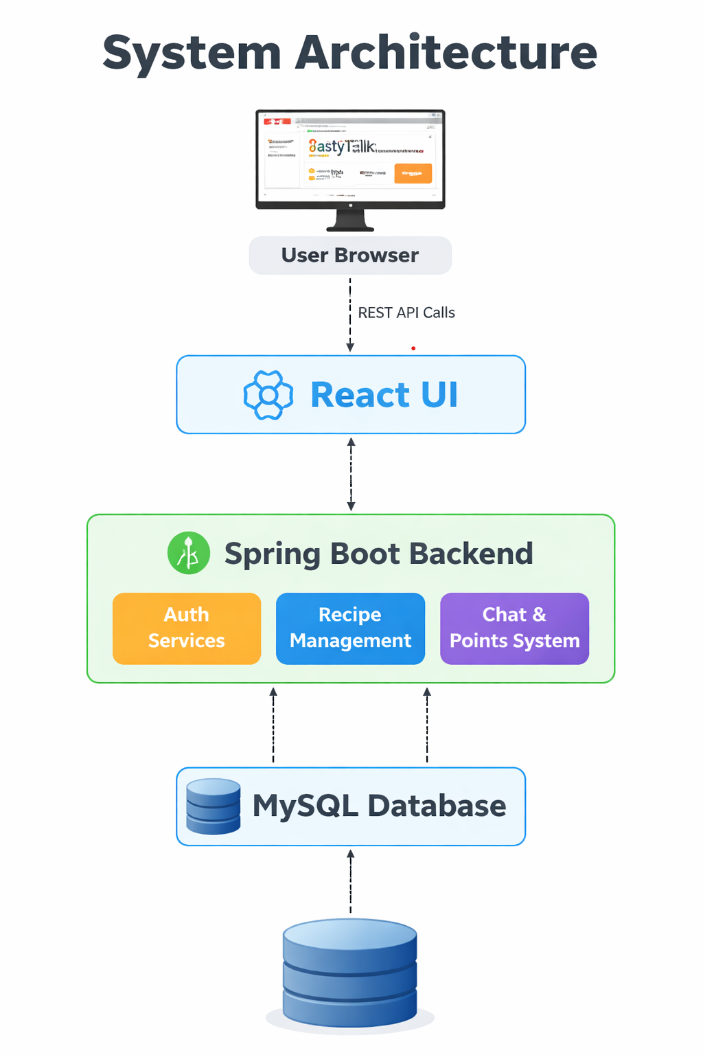
During the implementation phase, the project is developed in independent modules such as user authentication, recipe management, interaction system (likes, comments, ratings), community chat, leaderboard and points system, profile management, and admin moderation panel. Each module is integrated through REST APIs to ensure smooth communication between the frontend and backend. Special attention is given to validation, security, and data consistency to maintain the reliability of the platform. Real-time features such as chat and live updates are incorporated to enhance user engagement.
Finally, the system undergoes testing and validation, including unit testing, integration testing, and system testing to ensure all functionalities work correctly across different user roles. Performance, security, and usability testing are conducted to verify that the platform is scalable, secure, and user-friendly. This structured methodology ensures that TastyTalks is developed as a reliable, interactive, and well-organized social platform for food enthusiasts and chefs.

EXPERIMENTS
To evaluate the functionality, reliability, and performance of TastyTalks, a series of practical experiments were conducted after implementing each module of the system. These experiments were designed to test the behavior of the platform under different user roles—Foodie, Chef, and Admin—and to verify whether the system performs according to the intended design. The primary focus of these experiments was to ensure correct role-based access control, smooth interaction between modules, accurate data handling, real-time communication, and effective content moderation.
The first experiment focused on user authentication and role verification, where multiple users were registered as foodies, chefs, and admins. The system was tested to confirm that each role was granted appropriate permissions. It was observed that chefs were able to post recipes, foodies could interact through ratings and comments without posting content, and admins had full moderation control. This confirmed the correctness of JWT-based authentication and authorization mechanisms.
The second experiment tested the recipe posting and approval workflow. Chefs submitted various recipes with detailed ingredients and instructions, which were then reviewed by the admin before publishing. This experiment ensured that only admin-approved recipes appeared on the public recipe page, validating the moderation layer and content quality assurance process.
Another important experiment evaluated the search and filtering mechanism. Recipes were searched based on cuisine, category, difficulty level, and ingredients to observe the responsiveness and accuracy of the filtering system. The results showed that the system could quickly retrieve relevant recipes with minimal response time, enhancing user experience and usability.
Further experiments were conducted to verify user interaction features such as likes, ratings, comments, and bookmarks. Users interacted with multiple recipes simultaneously to ensure that the database was updated correctly and the changes were reflected instantly on the user interface. This confirmed the consistency of data synchronization between the frontend and backend.
The real-time community chat feature was also tested by allowing multiple users to send and receive messages concurrently. It was observed that messages were delivered instantly without page refresh, confirming the successful implementation of WebSocket-based communication. Additionally, the leaderboard and points system was tested by allowing chefs to post recipes and receive interactions. Points were calculated accurately based on user engagement and displayed correctly on the leaderboard.
Additionally, performance and usability testing were carried out to evaluate how the platform behaves under continuous usage and multiple user interactions. Different users accessed the system simultaneously to observe page loading time, API response time, and overall interface responsiveness. The system maintained stable performance without delays or crashes, demonstrating its scalability and efficient handling of requests. User feedback during testing also indicated that the interface was simple to navigate, and the workflow from browsing recipes to interacting with chefs was smooth and intuitive. This experiment validated that TastyTalks not only performs correctly from a technical perspective but also provides a user-friendly and engaging experience for its community members.
Finally, the admin moderation controls were tested thoroughly, including deleting inappropriate comments, managing user roles, approving recipes, and resetting weekly points. These actions worked as expected, demonstrating full administrative control over the platform.
Overall, these experiments confirmed that TastyTalks functions reliably across all modules, maintains data integrity, supports real-time interaction, and provides a secure, moderated, and user-friendly environment for food enthusiasts and chefs.

RESULTS
The TastyTalks system was successfully designed and implemented as a comprehensive web-based platform that facilitates structured interaction between food enthusiasts, chefs, and administrators. The application effectively demonstrates the integration of role-based access control, enabling different categories of users to perform distinct functionalities such as recipe creation, browsing, interaction, and moderation. The system allows chefs to publish recipes with detailed information, while users can explore content, provide feedback through ratings and comments, and engage in knowledge sharing. The administrative module ensures content quality by approving or rejecting submissions and managing inappropriate activities, thereby maintaining the reliability and integrity of the platform.
The implemented system exhibits efficient performance in handling multiple operations, including user authentication, data storage, and real-time interaction features. The frontend interface provides a responsive and user-friendly experience, allowing seamless navigation across different modules such as recipe browsing, profile management, and community interaction. The backend system ensures secure processing of user requests and efficient communication with the database for storing and retrieving structured data. The use of modern web technologies contributes to scalability, enabling the system to accommodate an increasing number of users and content over time.
The interaction mechanisms within the platform, such as commenting, rating, and bookmarking, enhance user engagement and promote active participation in the community. The structured format of recipe submission and categorization improves content organization, making it easier for users to discover relevant recipes. Additionally, the moderation system minimizes issues such as duplicate content, spam, and misinformation, which are commonly observed in existing platforms.
Overall, the results indicate that the TastyTalks platform successfully meets its intended objectives by providing a reliable, interactive, and scalable environment for recipe sharing and food-related discussions. The system demonstrates practical implementation of key software engineering concepts, including modular design, role-based systems, and user-centered interface development. The project highlights the effectiveness of integrating structured interaction with community-driven features to create a meaningful and engaging user experience.
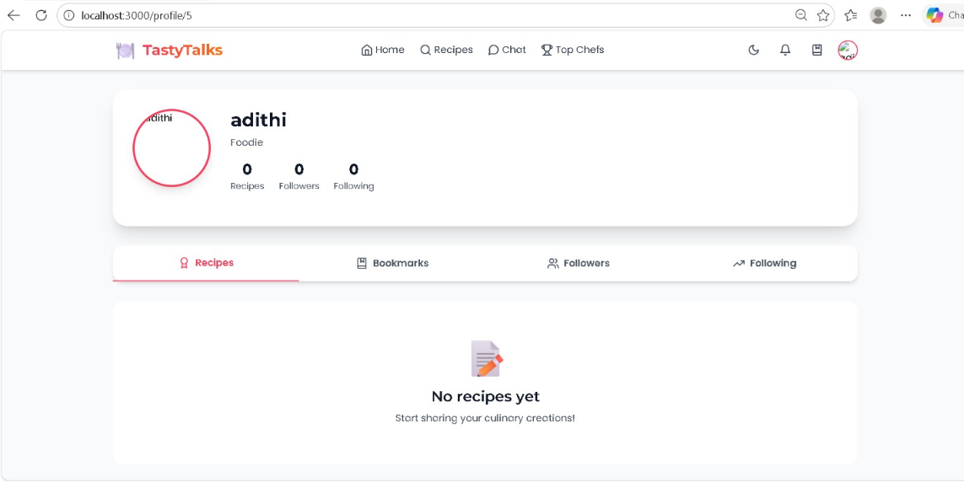

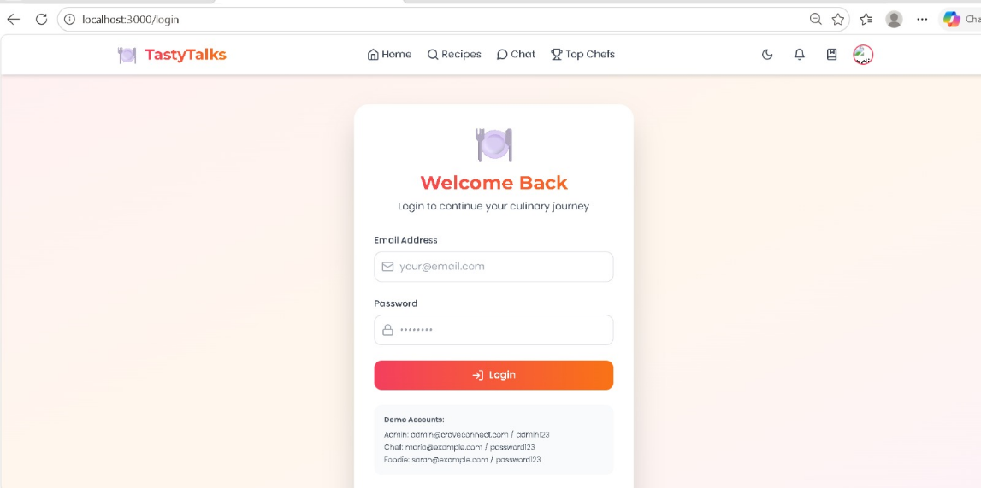

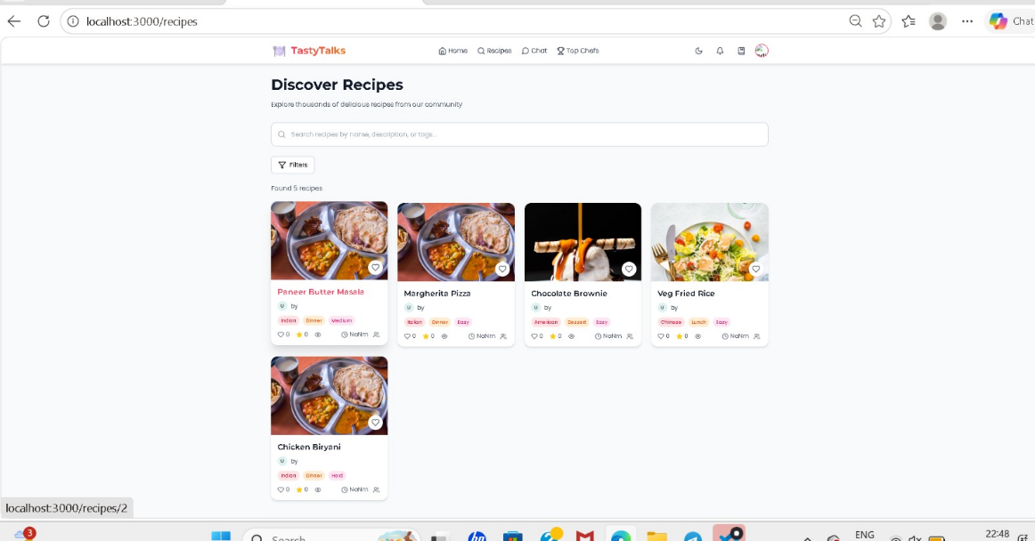

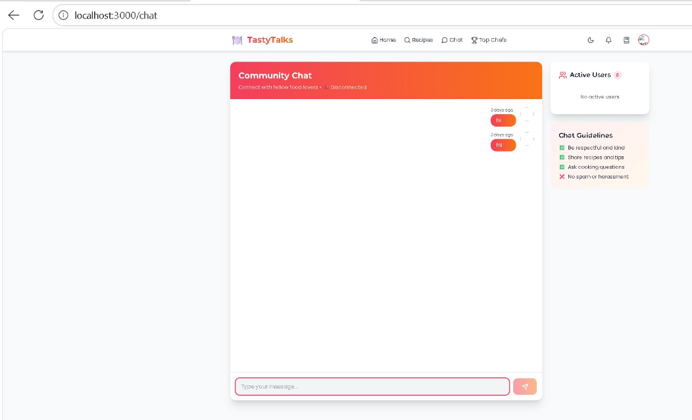
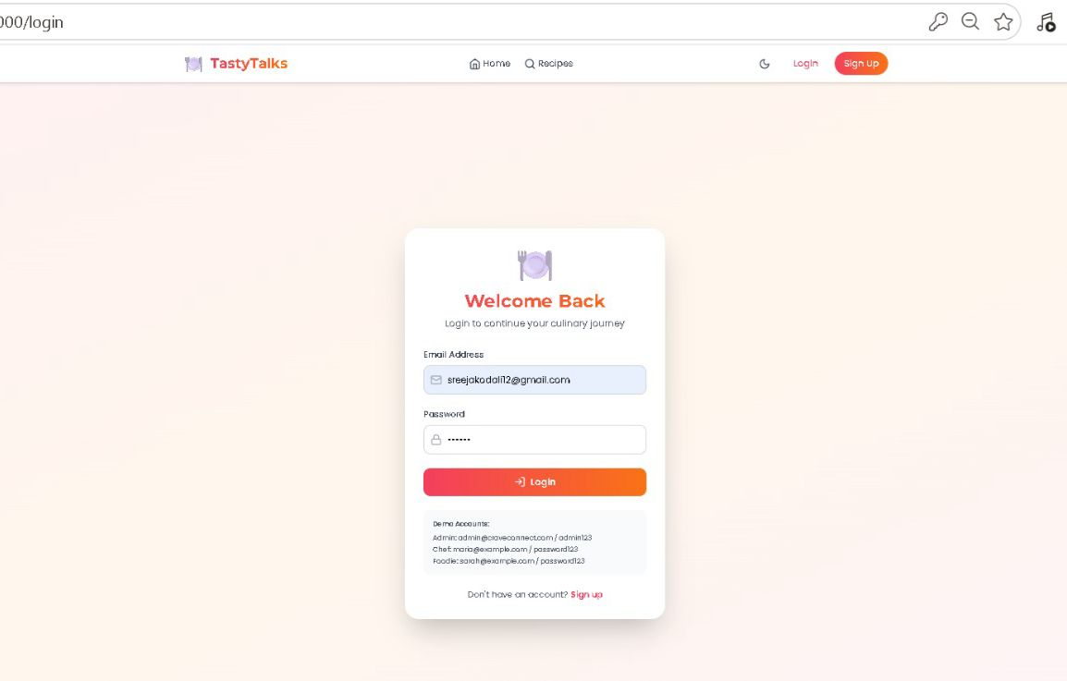
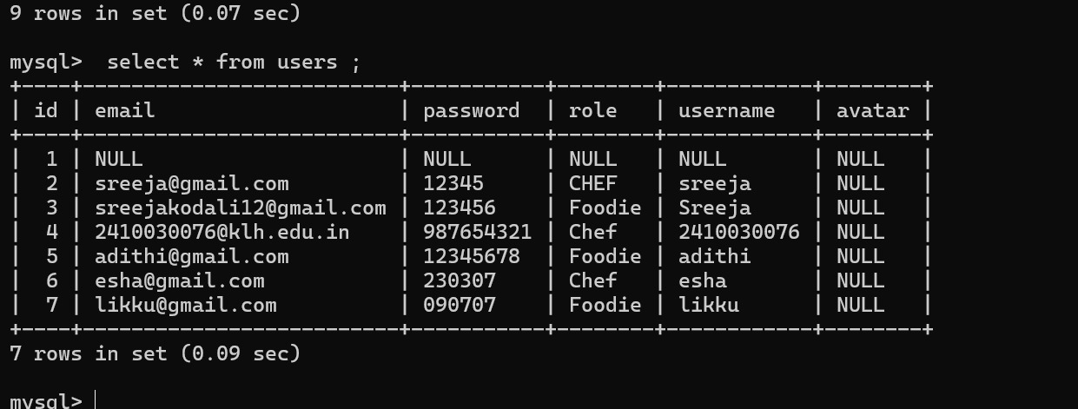

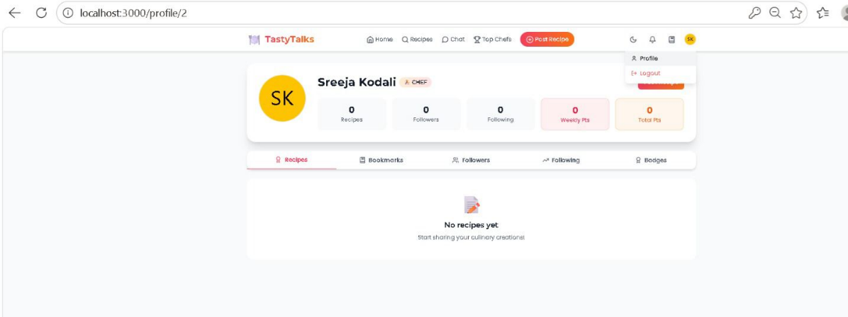
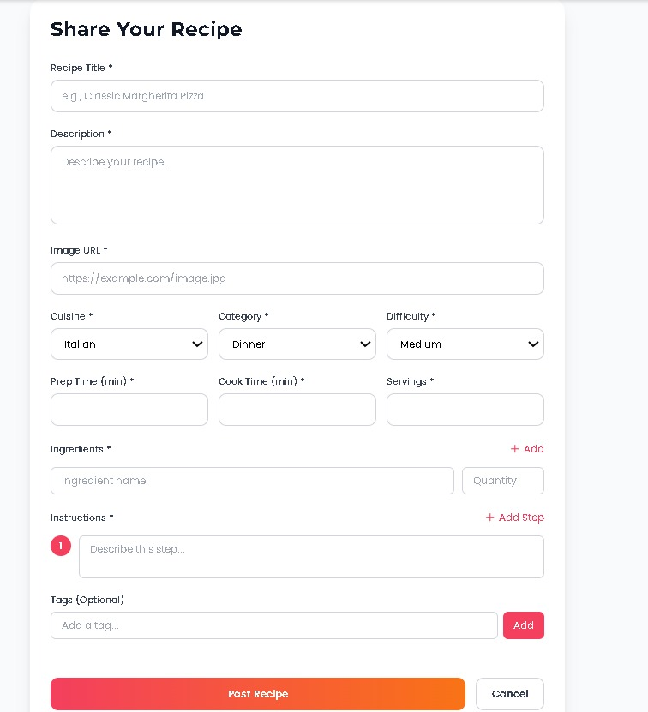

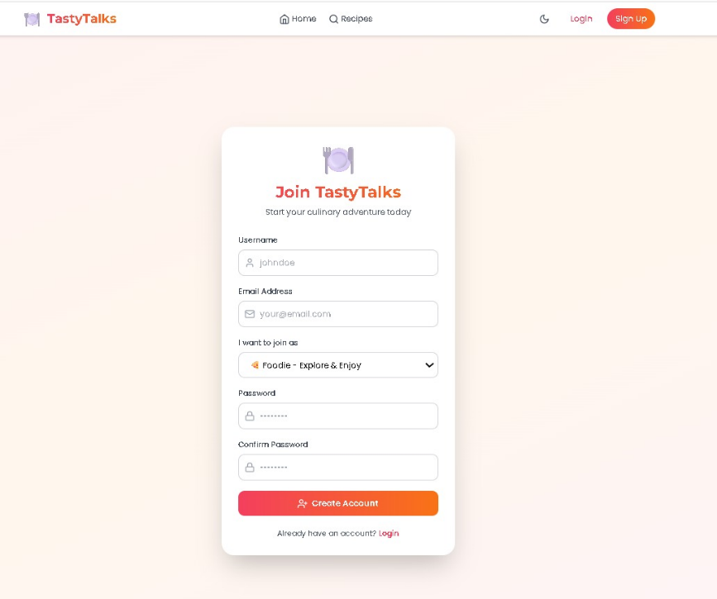
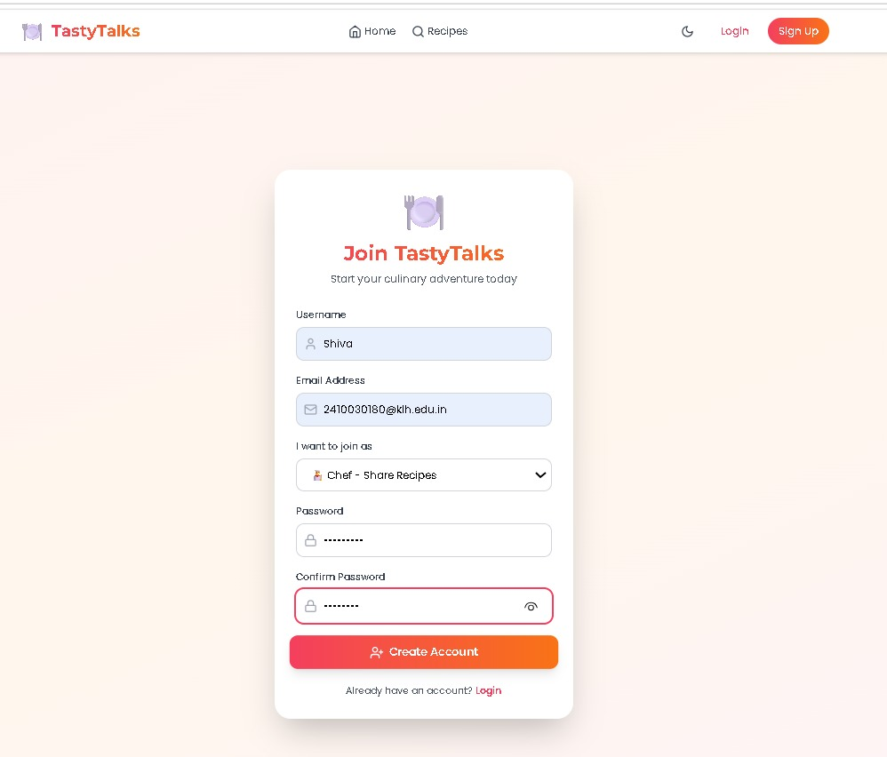
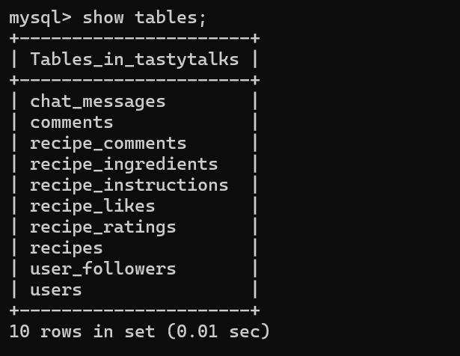

CONCLUSION and FUTURE WORK
The TastyTalks system has been successfully designed, developed, and evaluated as a comprehensive social platform tailored specifically for food enthusiasts and chefs. The primary objective of the project was to overcome the limitations of existing recipe-sharing platforms by introducing structured interaction, role-based access control, and content moderation. The results of the implementation clearly demonstrate that the system effectively meets these objectives by providing a reliable, interactive, and user-friendly environment for recipe sharing and culinary knowledge exchange.
The platform enables multiple categories of users, including foodies, chefs, and administrators, to interact within a well-defined framework. Each role is assigned specific permissions, ensuring controlled access and maintaining system integrity. Chefs can create and manage recipes, users can explore and interact through ratings and comments, and administrators can monitor and regulate content. This structured approach significantly improves content quality, user trust, and overall system efficiency compared to traditional platforms that lack such differentiation.
Furthermore, the implementation of interaction features such as commenting, rating, and bookmarking transforms the platform into a dynamic community rather than a static content repository. Users are encouraged to actively participate, share feedback, and engage in discussions, thereby enhancing the learning experience. The moderation system plays a crucial role in maintaining content quality by preventing spam, duplication, and misinformation, which are common challenges in existing systems.
From an academic perspective, the project successfully demonstrates the practical application of key software engineering principles, including modular design, database management, authentication mechanisms, and role-based system architecture. It also highlights the importance of user-centered design in developing scalable and maintainable applications. Overall, the successful implementation and evaluation of TastyTalks confirm that it is a viable solution for building a structured and interactive food-focused social platform.
Although the TastyTalks platform achieves its primary objectives, there are several opportunities for enhancement and expansion to further improve its functionality, scalability, and user experience. One of the major areas for future development is the integration of Artificial Intelligence to provide personalized recommendations. By analyzing user behavior, preferences, and interaction patterns, the system can suggest relevant recipes, chefs, and content, thereby improving user engagement and satisfaction.
Another important enhancement involves the expansion of real-time communication features. While the current system supports basic interaction through comments, future versions can include advanced chat functionalities such as private messaging, group discussions, and topic-based chat rooms. This would enable more direct communication between users and chefs, fostering a stronger sense of community.
The platform can also be extended by incorporating multimedia capabilities, such as video-based recipe uploads and live cooking sessions. These features would provide a more interactive and immersive learning experience compared to traditional text-based recipes. Additionally, the inclusion of voice-based search and smart filtering mechanisms can improve accessibility and make it easier for users to find relevant content based on ingredients, cuisine, or dietary preferences.
Mobile application development is another significant area of future work. Developing dedicated mobile applications for Android and iOS platforms would enhance accessibility and allow users to interact with the system more conveniently.
Security can also be strengthened by implementing advanced authentication techniques such as multi-factor authentication and encrypted data storage. This would ensure better protection of user data and enhance trust in the platform. Additionally, gamification elements such as badges, rewards, leaderboards, and achievement systems can be introduced to motivate users and encourage active participation.

References
- Kathleen C. Riley, Tasty Talk, expressive food http://semioticreview.com/sr/index.php/srindex/article/view/5
- Tim Sundell, The tasty, the bold, and the beautiful, https://www.tandfonline.com/doi/abs/10.1080/0020174X.2016.1208918
- Ines Crespo´ and Raquel Fernandez, Expressing Taste in Dialouge, https://staff.science.uva.nl/r.fernandezrovira/papers/2011/PPTinDialogue-semdial2011.pdf

